Lab No. 11 (1) : - output
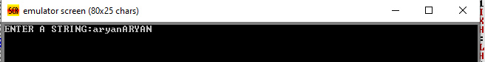

Lab No. 11(2) :- Output
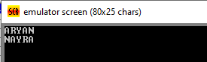

Lab No. 11(3) :- Output
